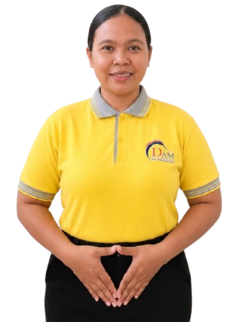

BIODATA
Applicants Information Sheet申請人資料

Name : HIKMAH HAYATI
Age : 36 Yo
Date of Birth : 05-08-1990
Place of birth : SUKADANA BARU
Gender : FEMALE
Address : DS. SUKADANA BARU RT. 018/005 LAMPUNG TIMUR
Religion : ISLAM
Last Education : SMA
Nationality : INDONESIA
Height : 155 cm
Weight : 75 Kg
Marital Status : MARRIED
Children : 1 ( 12 YO )

Family Background 家庭背景
Spouse Name, Age : IMAM HAMBALI
Occupation : FARMER
Father's Name, Age : M. KAMIDI
Occupation : FARMER
Mother's Name Age & : SUPARMI
Occupation : HOUSE WIFE
No. of children : 1
No. of brother/sister(s) : 2 SISTER
No HP Family : 085382000567 (HUSBAND)
- Do you eat pork? 你會否食豬肉? Yes ( ) No ()
- Can you handle pork你能否烹調豬肉菜式? Yes () No ( )
- Are you willing to share a room 你是否願意與嬰兒/兒童/或相同性別的人同住於一房間？Yes ( ) No ( )
- Can you take care of pets你會照顧狗 貓和雀鳥? Yes () No ( )
- Do you promise not to use cell phone or the landline at work?你是否答應不在工作時使用手提或有線電話? Yes ( ) No ( )
- Have you had any serious / prolonged illness?你曾否患過嚴重或長期性疾病？Yes ( ) No ()

Latest Employment Record最近工作紀錄
Country : INDONESIA
Name of employer : MAM YATI
Address : LAMPUNG
Family Members : 2
Baby : -
Eldery : -
Children : -
Adult : 2 ( MAM & SON 25 YO )
Size of house : LANDED
Duration : 2 yrs ( 2022-2024)
Salary : 2 juta

Job Duties 工作
(✔)Cooking
( )Infant Care
(✔)Washing/Ironing
( )Take Care of Baby
( )Take Care Of Children
( )Take Care Of Eldery
( )Take Care Of dog,cat
( )Take Care Of Disabled
(✔)Hand-Washing Clothes
(✔)Cleaning
( )Go to Market
( )Car Washing
( )Send & Pick up children
(✔) Gardening

Job Duties 工作
(✔)Cooking
( )Infant Care
(✔)Washing/Ironing
( )Take Care of Baby
(✔)Take Care of Children
( )Take Care of Eldery
( )Take Care of Dog
( )Take Care of Disabled
(✔)Hand-Washing Clothes
(✔)Cleaning
( )Go to Market
( )Car Washing
( )Send & Pick up children
( )Gardening

Previous Employment Record 2nd
Country :
Name of employer :
Address :
Family Members :
Baby : -
Eldery :-
Children :
Adult :
Size of house :
Duration :
Salary :

1
Job Duties 工作
( ) Cooking
( ) Infant Care
( ) Washing/Ironing
( )Take Care of Baby
( )Take Care Of Children
( )Take Care Of Eldery
( )Take Care Of Dog
( )Take Care Of Disabled
( )Hand-Washing Clothes
( )Cleaning
( )Go to Market
( )Car Washing
( )Send & pick up children
( )Gardening

Reason to Quit離開原因 :

Previous Employment Record 1st
Country :
Name of employer :
Address :
Family Members :
Baby :
Eldery :
Children :
Adult :
Size of house :
Duration :
Salary :

Reason to Quit離開原因: FINISH CONTRACT

My name is HIKMAH HAYATI I am 36 year old from LAMPUNG Of Indonesia . I have work experience in Indonesia , I am a friendly and hardworking person, I can cook Indonesian food and I am still learning Chinese food. I am not afraid of dogs & cats, I can take care of children , eldery & I can do House working. I want work in Malaysia because need money for family & my future.

Reason to Quit離開原因 :

