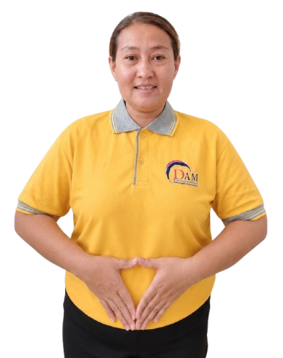

BIODATA
Applicants Information Sheet申請人資料

Name : KHOLIDAH
Age : 42 Yo
Date of Birth : 31-12-1984
Place of birth : MUARA SOMA
Gender : FEMALE
Address : DS. AMPEL RT. 003/015 SERANG
Religion : ISLAM
Last Education : SD
Nationality : INDONESIA
Height : 150 cm
Weight : 63 Kg
Marital Status : MARRIED
Children : 2 (21 YO & 8 YO )

Family Background 家庭背景
Spouse Name, Age : BAHTIAR
Occupation : LAWYER
Father's Name, Age : ALIAMSAR
Occupation : PASSED AWAY
Mother's Name Age & : DERHANI
Occupation : PASSED AWAY
No. of children : 2
No. of brother/sister(s) : 2 BROTHER & 1 SISTER
No HP Family : 085770773350 (HUSBAND)
- Do you eat pork? 你會否食豬肉? Yes ( ) No ()
- Can you handle pork你能否烹調豬肉菜式? Yes () No ( )
- Are you willing to share a room 你是否願意與嬰兒/兒童/或相同性別的人同住於一房間？Yes ( ) No ( )
- Can you take care of pets你會照顧狗 貓和雀鳥? Yes () No ( )
- Do you promise not to use cell phone or the landline at work?你是否答應不在工作時使用手提或有線電話? Yes ( ) No ( )
- Have you had any serious / prolonged illness?你曾否患過嚴重或長期性疾病？Yes ( ) No ()

Latest Employment Record最近工作紀錄
Country : INDONESIA
Name of employer : MAM SUHARTI
Address : TANGERANG
Family Members : 4
Baby : -
Eldery : -
Children : 2 ( 19 YO & 4 YO )
Adult : 2 ( MAM & SIR )
Size of house : 3 STOREY
Duration : 3 YRS ( 2020-2023)
Salary : 2,5 JUTA

Job Duties 工作
(✔)Cooking
( )Infant Care
(✔)Washing/Ironing
( )Take Care of Baby
(✔)Take Care Of Children
( )Take Care Of Eldery
( )Take Care Of dog,cat
( )Take Care Of Disabled
(✔)Hand-Washing Clothes
(✔)Cleaning
( )Go to Market
(✔)Car Washing
(✔)Send & Pick up children
( ) Gardening

Job Duties 工作
(✔)Cooking
( )Infant Care
(✔)Washing/Ironing
( )Take Care of Baby
(✔)Take Care of Children
( )Take Care of Eldery
( )Take Care of Dog
( )Take Care of Disabled
(✔)Hand-Washing Clothes
(✔)Cleaning
( )Go to Market
( )Car Washing
( )Send & Pick up children
( )Gardening

Previous Employment Record 2nd
Country :
Name of employer :
Address :
Family Members :
Baby : -
Eldery :-
Children :
Adult :
Size of house :
Duration :
Salary :

1
Job Duties 工作
( ) Cooking
( ) Infant Care
( ) Washing/Ironing
( )Take Care of Baby
( )Take Care Of Children
( )Take Care Of Eldery
( )Take Care Of Dog
( )Take Care Of Disabled
( )Hand-Washing Clothes
( )Cleaning
( )Go to Market
( )Car Washing
( )Send & pick up children
( )Gardening

Reason to Quit離開原因 :

Previous Employment Record 1st
Country :
Name of employer :
Address :
Family Members :
Baby :
Eldery :
Children :
Adult :
Size of house :
Duration :
Salary :

Reason to Quit離開原因: FINISH CONTRACT

My name is KHOLIDAH I am 42 year old from SERANG Of Indonesia . I have work experience in INDONESIA , I am a friendly and hardworking person, I can cook Indonesian food and I am still learning Chinese food. I am not afraid of dogs & cats, I can take care of children , eldery & I can do House working. I want work in Malaysia because need money for family & my future.

Reason to Quit離開原因 :

