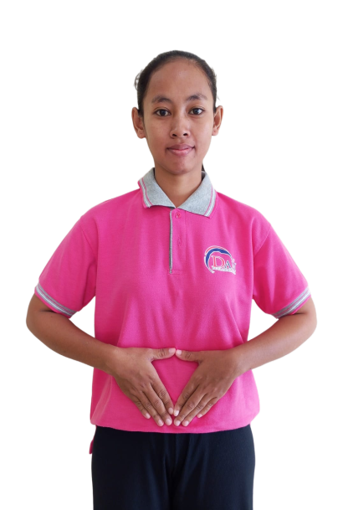
BIODATA
Applicants Information Sheet申請人資料

Name : ROJINAH
Age : 27 yo
Date of Birth : 11-10-1998
Place of birth : CIREBON
Gender : FEMALE
Address : CIREBON-JAWA BARAT
Religion : MOSLEM
Last Education : SMP
Nationality : INDONESIA
Height : 159 cm
Weight : 47 Kg
Marital Status : MARRIED
Children : 2

Family Background 家庭背景
Spouse Name, Age : ABDUL HASIM (32YO)
Occupation : CONSTRUCTION WORKER
Father's Name, Age : WASRUM (60YO)
Occupation : FARMER
Mother's Name Age & : WASIAH (60YO)
Occupation : FARMER
No. of children : 2
No. of brother/sister(s) : 4
No HP Family : 087846470018

- Do you eat pork? 你會否食豬肉? Yes ( ) No ()
- Can you handle pork你能否烹調豬肉菜式? Yes () No ( )
- Are you willing to share a room 你是否願意與嬰兒/兒童/或相同性別的人同住於一房間？Yes ( ) No ( )
- Can you take care of pets你會照顧狗 貓和雀鳥? Yes () No ( )
- Do you promise not to use cell phone or the landline at work?你是否答應不在工作時使用手提或有線電話? Yes ( ) No ( )
- Have you had any serious / prolonged illness?你曾否患過嚴重或長期性疾病？Yes ( ) No ()

Latest Employment Record最近工作紀錄
Country : INDONESIA
Name of employer :
Address : TANGERANG
Family Members : 7 MEMBERS
Baby :
Eldery :
Children : 5 (4 adult, 1 6yo)
Adult : 2(MAM,SIR)
Size of house : 2 STOREY HOUSE
Duration : 2013-2016 (3YEARS)
Salary : RP 600.000

Job Duties 工作
(✔)Cooking
( )Infant Care
(✔)Washing/Ironing
( )Take Care of Baby
(✔)Take Care Of Children
( )Take Care Of Eldery
( )Take Care Of dog,cat
( )Take Care Of Disabled
( )Hand-Washing Clothes
(✔)Cleaning
( )Go to Market
( )Car Washing
( )Send & Pick up children
( )Gardening

Job Duties 工作
( )Cooking
( )Infant Care
( )Washing/Ironing
( )Take Care of Baby
( )Take Care of Children
( )Take Care of Eldery
( )Take Care of Dog
( )Take Care of Disabled
( )Hand-Washing Clothes
( )Cleaning
( )Go to Market
( )Car Washing
( )Send & Pick up children
( )Gardening

Previous Employment Record 2nd
Country :
Name of employer :
Address :
Family Members :
Baby :
Eldery :
Children :
Adult :
Size of house :
Duration :
Salary :

1
Job Duties 工作
() Cooking
( ) Infant Care
() Washing/Ironing
( )Take Care of Baby
( )Take Care Of Children
()Take Care Of Eldery
( )Take Care Of Dog
( )Take Care Of Disabled
( )Hand-Washing Clothes
( )Cleaning
()Go to Market
( )Car Washing
( )Send & pick up children
( )Gardening

Previous Employment Record 1st
Country :
Name of employer :
Address :
Family Members :
Baby :
Eldery :
Children :
Adult :
Size of house :
Duration :
Salary :

Reason to Quit離開原因:

Reason to Quit離開原因: FINISH CONTRACT

My name is Rojinah I am 27 years old from Cirebon Of Indonesia. I have work experience in Indonesia, I am a friendly and hardworking person, I can cook Indonesian food and I am still learning Chinese food. I am not afraid of dogs & cats, I can take care of children, eldery & I can do House working. I want work in Malaysia because need money for family & my future.

Reason to Quit離開原因 :

